**Radio Manager**

**User Guide**

**Introduction**

This document is a part of the *Radio Manager* WordPress plugin that is a proprietary software belonging to the Czech-American TV (abbreviated as ‘CATV’ in the following). The software can be used only at the CATV’s test and production websites. If you have found it elsewhere, please contact the author of the plugin. It is forbidden to use it on the other websites without a permission of the CATV.

The document serves as a user guide and manual for the *Radio Manager* WordPress plugin. As a new user of this software, you should read the whole guide for a complete understanding. If you are an advanced user, look at the table of contents below and read the chapter you are interested in.

**Table of contents**

1 Dependencies 1

2 Installation 1

3 Uninstallation 3

4 PART 1: Basics 4

4.1 Features 4

4.2 Shuffle mode 4

4.3 Different playlist 5

5 PART 2: Website 5

5.1 Videos 5

5.2 Images 6

5.3 Description 7

5.4 Description (no images) 8

5.5 Logo 9

5.6 Website posts 10

5.7 Warnings 10

5.8 Preloader 11

5.9 Understand the multimedia rule 12

6 PART 3: Administration 12

6.1 Radio stations 13

6.2 Editing a radio station 14

6.2.1 Name 14

6.2.2 Logo 15

6.2.3 Shortcode 15

6.2.4 Publish 16

6.2.5 Settings 17

6.2.6 Playlist 17

6.2.7 Warnings 18

6.3 Musicians 20

6.4 Editing a musician 20

6.4.1 Name 21

6.4.2 Description 21

6.4.3 Featured image 21

6.4.4 Genres 22

6.4.5 Publish 23

6.4.6 Images 23

6.4.7 Introductions 25

6.4.8 Recordings 26

6.5 Genres 28

7 PART 4: Bonus features 29

7.1 Customize the appearance 29

7.2 Clever images 29

7.3 Extended logo 30

8 Contact 30

# 1 Dependencies

To make the plugin work properly, you must have the following WordPress plugins installed and activated:

* Advanced Custom Fields
* Advanced Custom Fields: Repeater Field
* s2Member Framework

Do not expect 100 % functionality if any of the higher plugins is missing. Your website should also have **the Bootstrap library (version 4.6)** installed. Contact your webmaster to get more information about it.

# 2 Installation

We expect you to be an administrator.

1. Contact the author to get a ZIP archive of the plugin.
2. Log into your WordPress account.
3. Go to the *Plugins > Add New* in the WordPress navigation menu on the left.

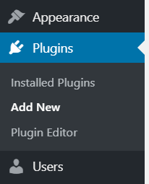

1. Click on the *Upload Plugin* button on top of the page. Find the ZIP archive of the plugin in your computer and click on the *Install Now* button to start the installation process.

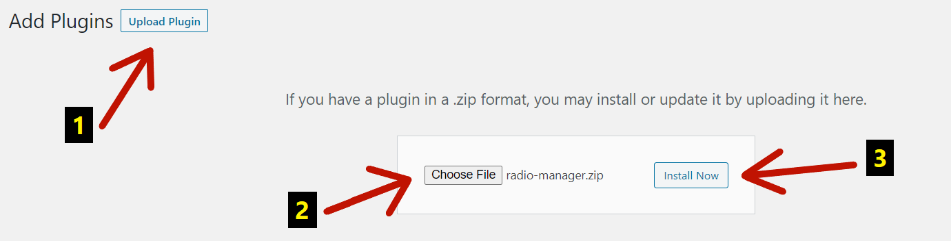

1. After the installation, activate the plugin by clicking on the *Activate Plugin* button.

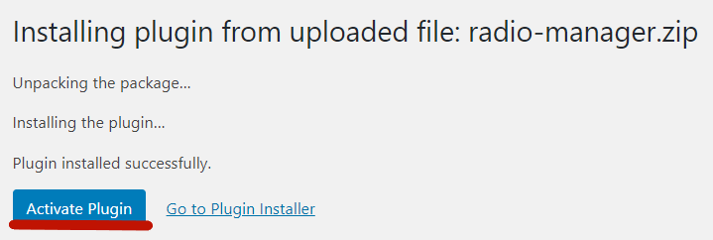

1. Find the plugin in the *Plugins > Installed Plugins* and click on the *Help* link nearby to continue reading this user guide right in the administration.



1. You have successfully done the installation.

# 3 Uninstallation

We expect you to be an administrator.

1. Log into your WordPress account.
2. Go to the *Plugins > Installed Plugins* in the WordPress navigation menu.

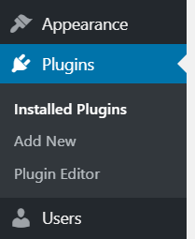

1. Find the plugin in the list and click on the *Deactivate* link nearby.



1. After that, click on the *Delete* link and confirm the uninstallation.



1. You have successfully done the uninstallation.

# 4 PART 1: Basics

The *Radio Manager* WordPress plugin is a software that enables you to create

e-radios for your website.

## 4.1 Features

An e-radio (also ‘radio’, ‘radio station’ or ‘jukebox’) can do the following things:

* play audio/video recordings,
* play audio/video introductions (e.g. entries by an e-radio presenter),
* project images (with the title and description of each),
* project other posts from the website,
* show the musician and recording names,
* show the musician description,
* show the e-radio logo,
* show the e-radio name,
* show dialogs (so called ‘warnings’) that interrupt the playback and prompt the listener to do some action.

## 4.2 Shuffle mode

*‘Shuffle play is a mode of music playback in which songs are played in a randomized order that is decided upon for all tracks at once.’ – Wikipedia*

* All the **musicians** attached to a particular music genre are shuffled.
* All the **images**, **introductions** and **recordings** attached to a particular musician are shuffled.
* If all the musicians, introductions or recordings were played, they are **shuffled again** (except the images).

## 4.3 Different playlist

The **e-radio** has a **playlist**. The playlist is composed of **playlist items** that are being played one after another. But playlist items ARE NOT recordings (as everyone would expect). Every playlist item is a particular music genre you can set. A **genre** is a group of musicians (e.g. *Folk*, *Classical* and also *Announcements*, *Jingles* etc.). A **musician** has all the recordings you hear in the e-radio.

When the e-radio starts to play, it sets the first playlist item (music genre) from the playlist. Then, it sets a musician from this genre. Finally, it sets a recording from this musician to be played (and also images to be shown etc.). Both musicians and recordings are shuffled (see above). The whole process continues for other playlist items. This is the main principle of all e-radios. If you get it, you get the whole plugin.

# 5 PART 2: Website

You can insert the e-radio into an arbitrary WordPress post or page (details in the next chapter). After that, there is a blue-styled responsive universal jukebox on the website. The jukebox can do all the things mentioned in the *Features* in the previous chapter. It is also accessible for all your website visitors who can enjoy it. Let us describe the jukebox and all the situations that might happen.

## 5.1 Videos

This is the jukebox playing the *Support Us* video recording by the *CATV* musician.

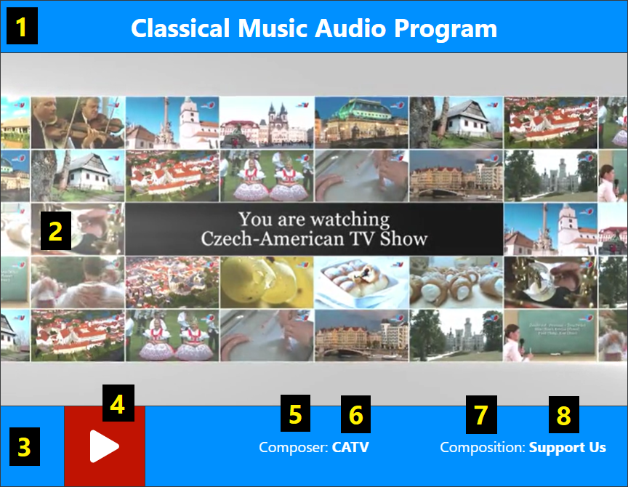

1. A field for the **name** of the e-radio.
2. A field for the **multimedia** (the video in this case).
3. A field for the e-radio **controls and information**.
4. A button that can **play or pause** the playback.
5. A **caption** for a musician’s name.
6. The **musician’s name**.
7. A **caption** for a recording’s name.
8. The **recording’s name**.

## 5.2 Images

This is the jukebox playing the *A Pair in Love* audio recording by the *Vitezslav Novak* musician. It is also projecting images of this musician (even if you stop the playback). Each image is shown for a specific length of time (e.g. three seconds). The transition between images is *fade*.

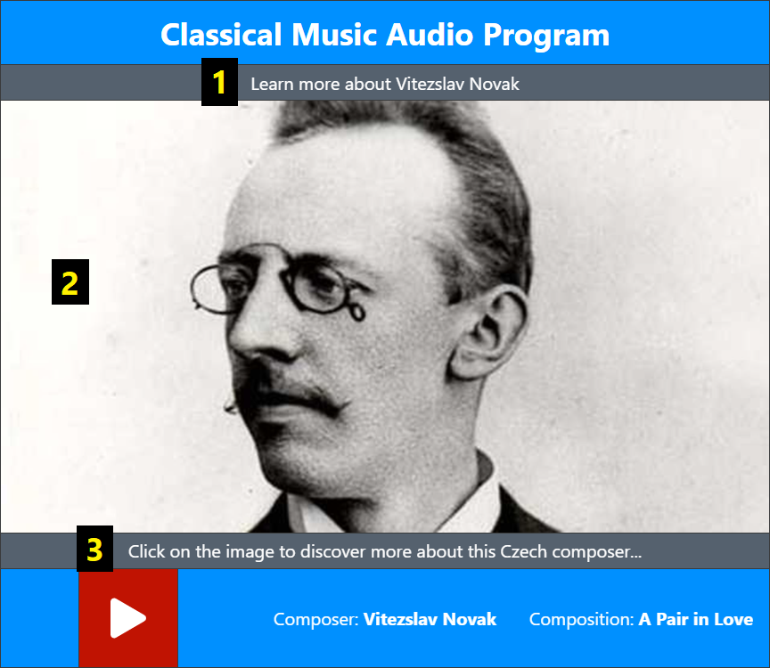

1. The **top title** of the particular image.
2. The particular **image** of the musician.
3. The **bottom title** of the particular image.

## 5.3 Description

In case of *Images*, you can click on the particular image. After that, there is a musician’s description you can read.

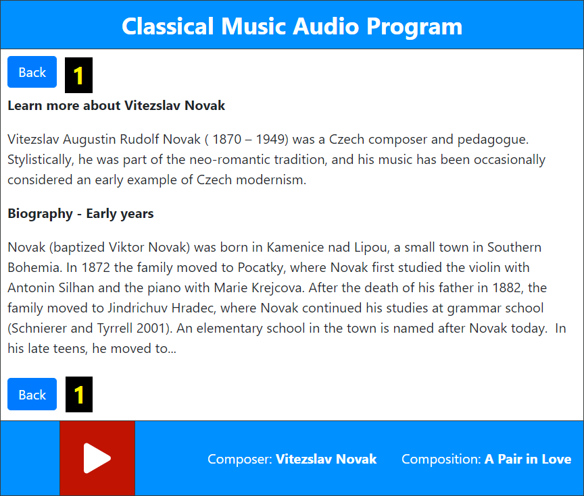

1. With the help of the *Back* buttons, you can return back on the images.

## 5.4 Description (no images)

If the musician has no images, there is the description by default (notice that there are no *Back* buttons). If the description is very long, there is a side slider for scrolling up and down.

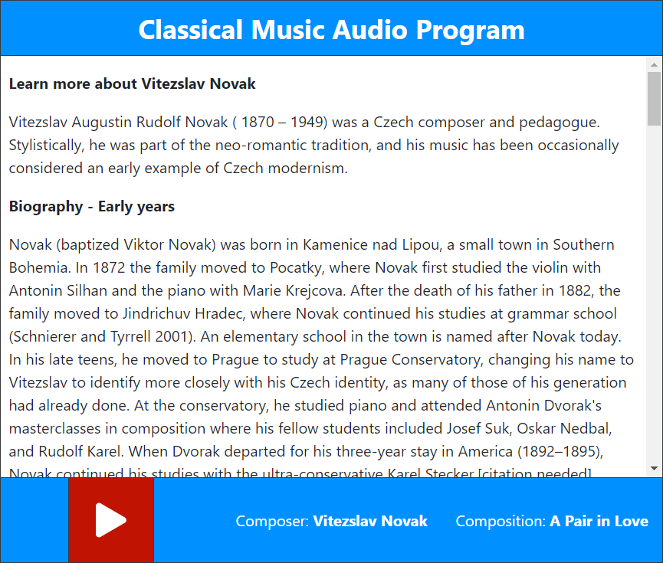

## 5.5 Logo

If there are no images nor description, there is a logo of the e-radio by default.



## 5.6 Website posts

There is a possibility to project some website posts in the e-radio. It can be useful if all the musicians have no images nor descriptions. In this case, there is a **featured image** of that website post accompanied by the top and bottom title of that image. If you click on the featured image, there is the **content** of the website post. The website posts are **shuffled**. A particular post is shown for the whole length of the recording. If the next recording starts to play, another website post shows. For instance, we have no images nor descriptions for the music bands in the Folk Music Audio Program. Therefore, we project posts about folk traditions from the website.

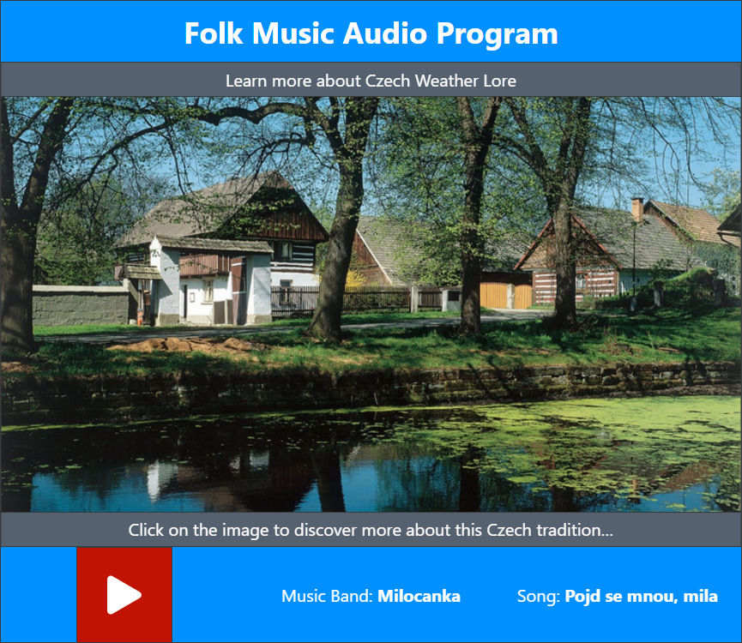

## 5.7 Warnings

These dialogs interrupt the playback and require a listener’s attention. They can be used for example as a prevention against the streaming losses or as an adverts. Every warning comes with a dark grey background to center the listener’s attention onto it.

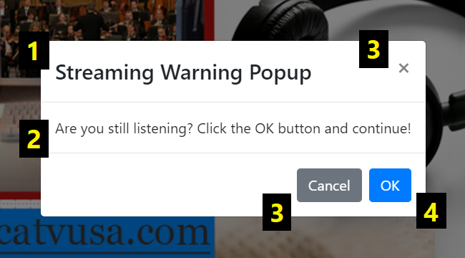

1. The **title** of the warning.
2. The **message** of the warning.
3. The ways how to **finish** the warning and continue listening.
4. The *OK* button can also finish the warning, but it can be used to redirect the listener to the new URL link in a new tab after clicking it.

## 5.8 Preloader

If an image or video have a high quality or your internet connection is slow, there is a small white preloader turning around while all these multimedia are loading.

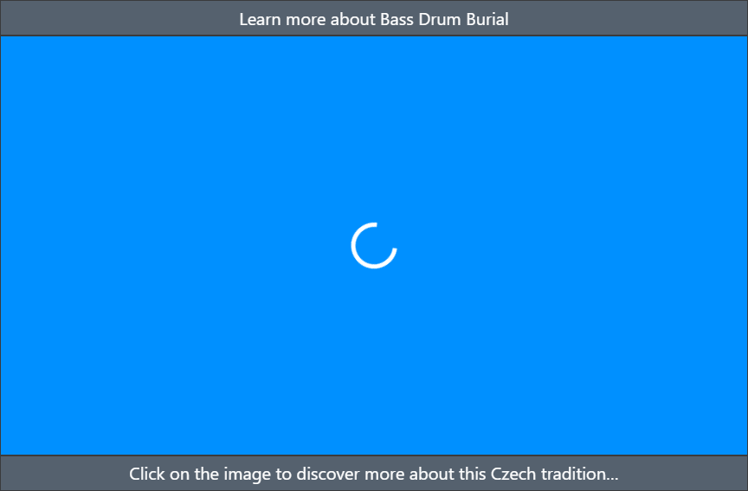

## 5.9 Understand the multimedia rule

This is the multimedia rule:

**Videos > Website posts > Images > Description > Logo**

* If the e-radio plays a **video** recording, everything to the right is hidden.
* If the e-radio plays an audio recording and the **website posts** are activated, everything to the right is hidden.
* If the e-radio plays the audio recording and the website posts are deactivated, there are **images** attached to a musician and everything to the right is hidden.
* If the musician has no images, there is just a **description** attached to him and everything to the right is hidden.
* If the musician has no images nor description, there is a **logo** of the e-radio.
* If the e-radio has no logo, there is simply **nothing**.

# 6 PART 3: Administration

You can manage all the e-radios, musicians and genres in the WordPress administration. At first, log into your WordPress account. After that, move the mouse on the *Radio Manager* item in the WordPress navigation menu on the left.

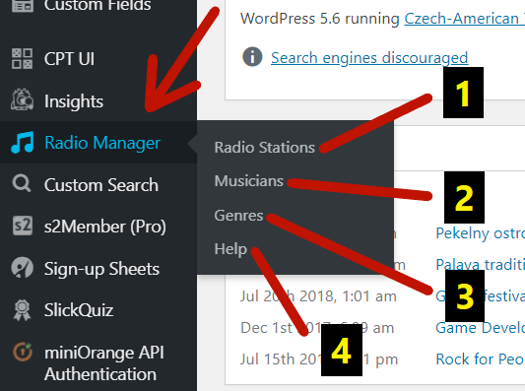

1. There you can manage all the **e-radios**.
2. There you can manage all the **musicians**.
3. There you can manage all the **music genres**.
4. There you can find **this document**.

If you cannot find the item, you probably do not have respective user capabilities. You must be able to **edit posts** at least (e.g. editors have this capability). In this case, you can see only *Musicians* and *Help*. If you can **manage options** (e.g. administrators have this capability), you can see everything on the image above.

## 6.1 Radio stations

After clicking on the *Radio Stations* item in the submenu, you can see a list with all the existing e-radios.

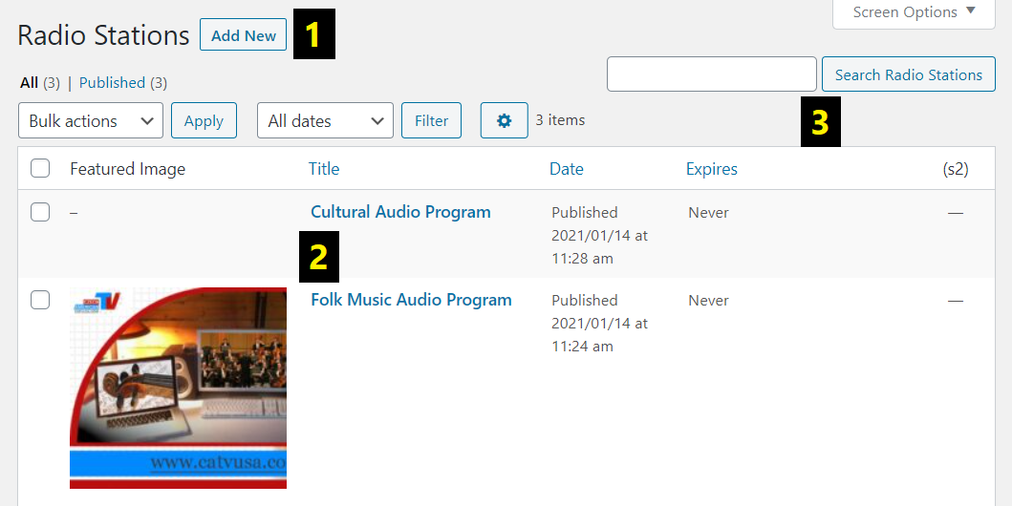

1. There you can **start creating** a new e-radio.
2. There is **the list** of all the existing e-radios that you can manage.
3. There you can **search** an existing e-radio from the list.

## 6.2 Editing a radio station

After clicking on the specific e-radio or creating a new one, you will land on the editing page. Let us show everything this page contains and everything you can set.

### 6.2.1 Name

The name is shown in the jukebox on top.



### 6.2.2 Logo

The logo is shown in the jukebox by default.

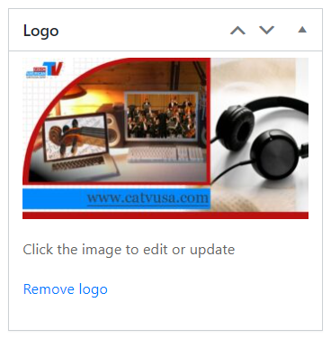

### 6.2.3 Shortcode

This is the way how you can **import a jukebox** into an arbitrary WordPress post or page. Just click on the *Copy* button, find a particular post or page and insert the shortcode to the content. After opening the post or page on the website, you will see the jukebox.

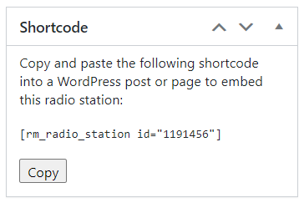

### 6.2.4 Publish

Every time you change something, go here to **update or publish** all the changes.

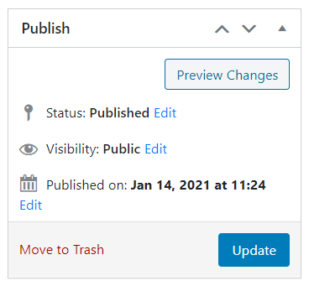

### 6.2.5 Settings

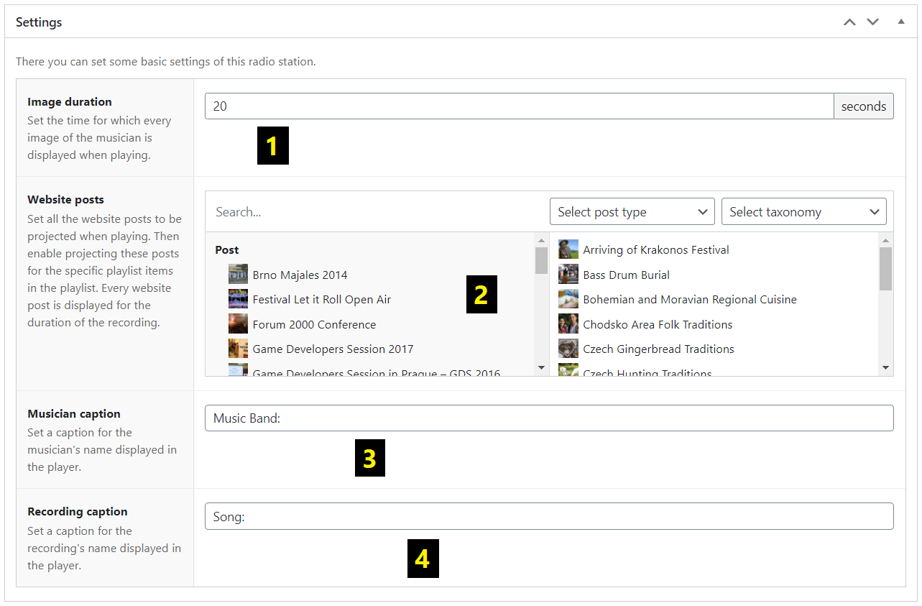

1. *Image duration* – There you can set the time (in seconds) for which every image of the musician is displayed when playing.
2. *Website posts* – There you can set all the website posts to be projected when playing. But you must enable projecting these posts for the specific playlist items in the playlist below.
3. *Musician caption* – There you can set a caption for the musician’s name displayed in the jukebox.
4. *Recording caption* – There you can set a caption for the recording’s name displayed in the jukebox.

### 6.2.6 Playlist

There you can add, edit, swap, or delete the playlist items of the playlist. There must be at least one playlist item. For each of the playlist items, the specific music genre must be set.

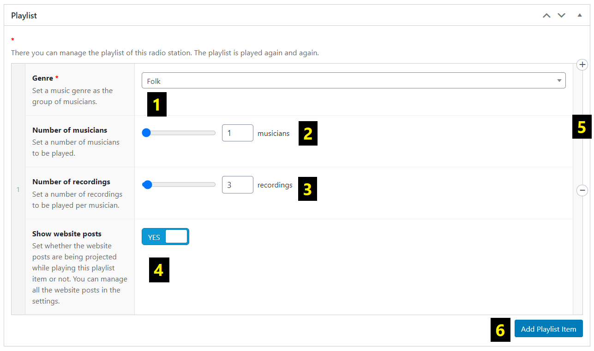

1. *Genre* – There you can set a music genre as the group of musicians.
2. *Number of musicians* – There you can set the number of musicians to be played.
3. *Number of recordings* – There you can set the number of recordings to be played per musician.
4. *Show website posts* – There you can set whether the website posts are being projected while playing this playlist item or not.
5. After moving the mouse on the specific playlist item, you can delete it or even add a new one by clicking on the *Plus* or *Minus* icon on the right.
6. There you can add a new playlist item composed of the previous information – *Genre*, *Number of musicians*, *Number of recordings*, *Show website posts*.

### 6.2.7 Warnings

There you can add, edit, swap, or delete the warnings. For every warning, the message must be set.

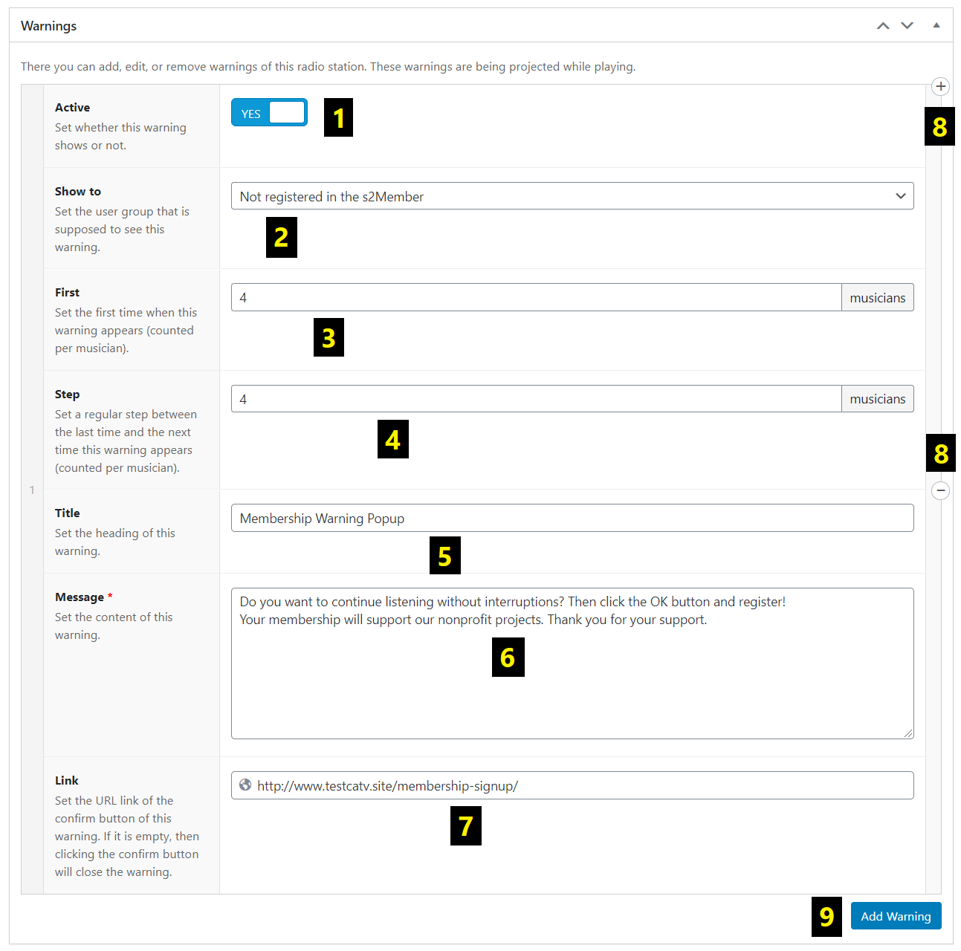

1. *Active* – There you can set whether this warning shows or not.
2. *Show to* – There you can set the user group that is supposed to see this warning (for example *All users*).
3. *First* – There you can set the first time when this warning appears (counted per musician).
4. *Step* – There you can set a regular step between the last time and the next time this warning appears (counted per musician)
5. *Title* – There you can set the heading of this warning.
6. *Message* – There you can set the content of this warning.
7. *Link* – There you can set the URL link of the confirm button of this warning. If it is empty, then clicking on the confirm button will close the warning. If not, the listener is redirected to the URL link in a new tab of browser after clicking.
8. After moving the mouse on the specific warning, you can delete it or even add a new one by clicking on the *Plus* or *Minus* icon on the right.
9. There you can add a new warning composed of the previous information – *Active*, *Show to*, *First*, *Step*, *Title*, *Message*, *Link*.

## 6.3 Musicians

After clicking on the *Musicians* item in the submenu, you can see a list with all the existing musicians.

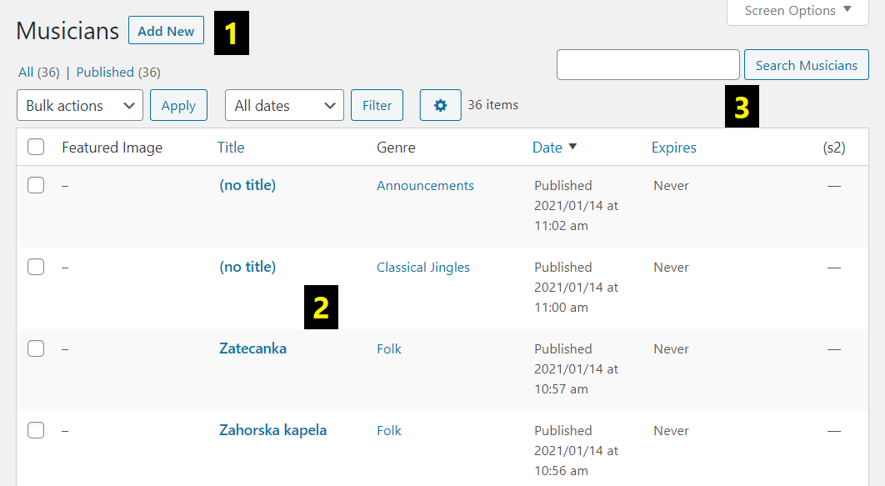

1. There you can **start creating** a new musician.
2. There is **the list** of all the existing musicians that you can manage.
3. There you can **search** an existing musician from the list.

## 6.4 Editing a musician

After clicking on the specific musician or creating a new one, you will land on the editing page. Let us show everything this page contains and everything you can set.

### 6.4.1 Name

The name is displayed in the jukebox next to the musician’s caption.

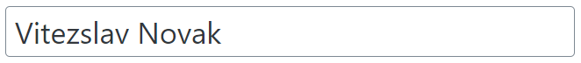

### 6.4.2 Description

The description appears after clicking on the projected images.

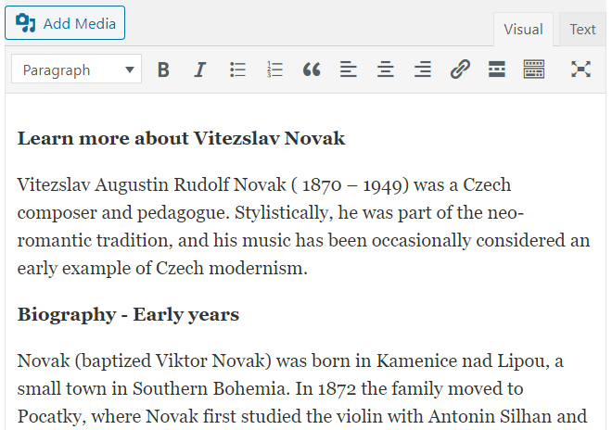

### 6.4.3 Featured image

This image just represents the musician in a respective list. It does not show anywhere in the jukebox.

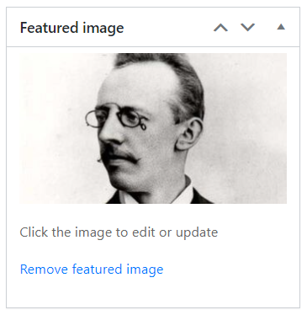

### 6.4.4 Genres

If you assign the musician to a specific genre, he can be played in the playlist.

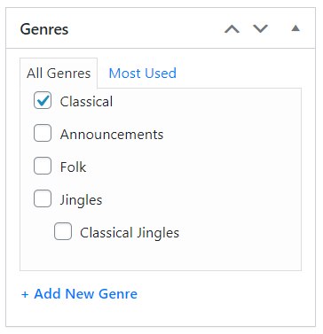

### 6.4.5 Publish

Every time you change something, go here to **update or publish** all the changes.

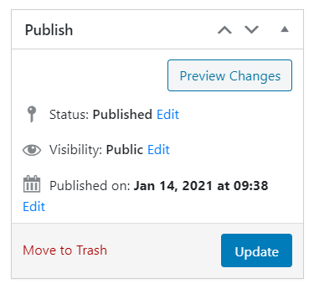

### 6.4.6 Images

There you can add, edit, or delete images of the musician. The images are being projected while playing recordings from the musician. All the images of the particular musician should have **the same width and height**. To add, if you set **a top title** or **a bottom title** for one image (see below), it should be set also in the remaining images. If you move the mouse on the particular image, then the *Pencil*, *Delete*, *Minus* and *Plus* icons appear nearby.

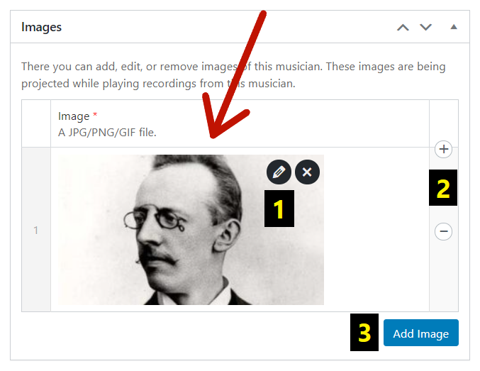

1. By clicking on the *Pencil* icon, you can change **the top and the bottom title** of the image.

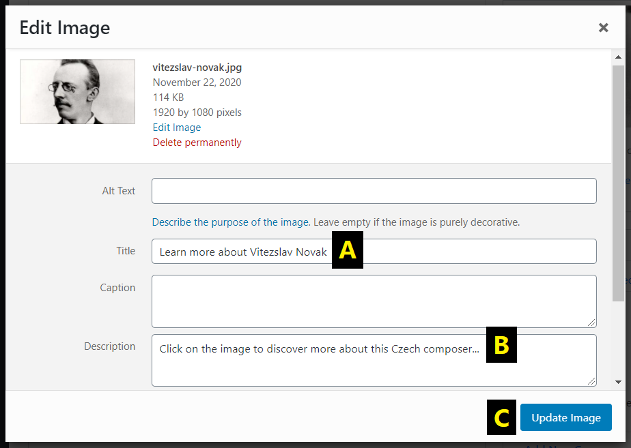

1. There you can edit **the top title** of the image.
2. There you can edit **the bottom title** of the image.
3. There you can **update** all the changes.
4. By clicking on the *Plus* or *Minus* icon, you can **add or remove** the image.
5. There you can **add** a new image (from your computer or the Media Library).

### 6.4.7 Introductions

There you can add, edit, or delete audio/video introductions of the musician. Before playing the recordings of the musician, one of them is set and played. Introductions are **shuffled** and can be used for example as the entries of an e-radio presenter. Their names are ignored and not displayed in the player (apart from the recordings). If you move the mouse on the introduction, then the *Minus* and *Plus* icons appear nearby.

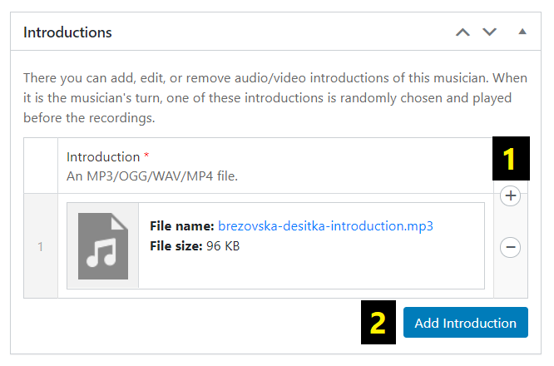

1. By clicking on the *Plus* or *Minus* icon, you can **add or remove** the introduction.
2. There you can **add** a new introduction (from your computer or the Media Library).

### 6.4.8 Recordings

There you can add, edit, or delete audio/video recordings of the musician. For every musician, there must be one recording at least. If you move the mouse on the recording, then the *Pencil*, *Delete*, *Minus* and *Plus* icons appear nearby.

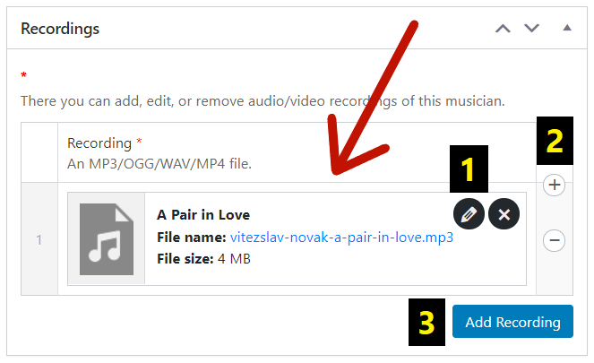

1. By clicking on the *Pencil* icon, you can change **the name** of the recording that is displayed next to the recording’s caption.

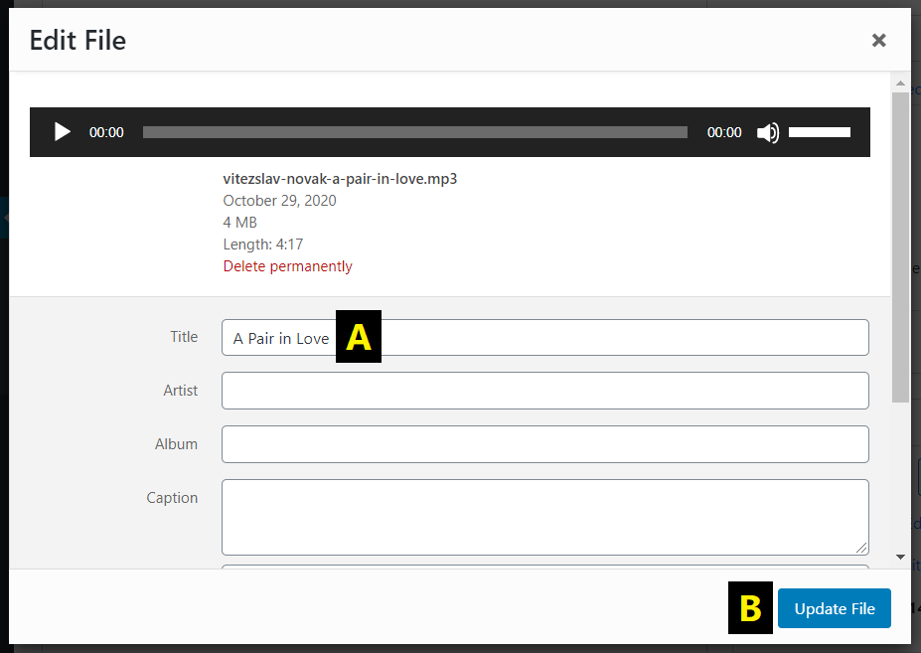

1. There you can edit **the name** of the recording.
2. There you can **update** all the changes.
3. By clicking on the *Plus* or *Minus* icon, you can **add or remove** the recording.
4. There you can **add** a new recording (from your computer or the Media Library).

## 6.5 Genres

After clicking on the *Genres* item in the submenu, you can see a list with all the existing genres. Genres are very important for creating the playlist.

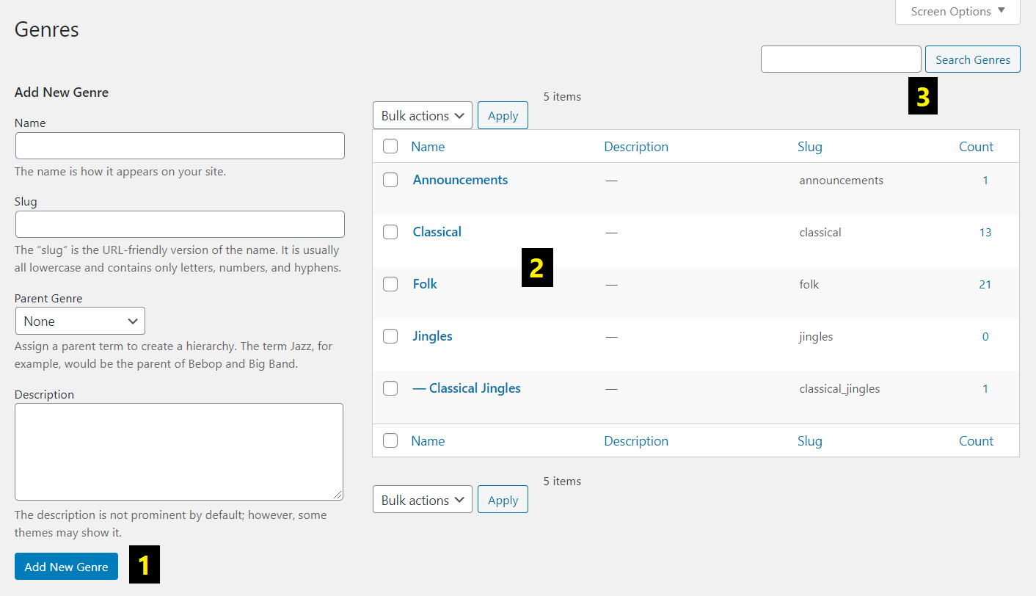

1. There you can **create** a new genre.
2. There is **the list** of all the existing genres that you can manage.
3. There you can **search** an existing genre from the list.

# 7 PART 4: Bonus features

## 7.1 Customize the appearance

If you are familiar with HTML and CSS, you can customize all the text outputs of an e-radio in the WordPress administration. For instance, you can set all captions to be written in italics.

In the **administration**:

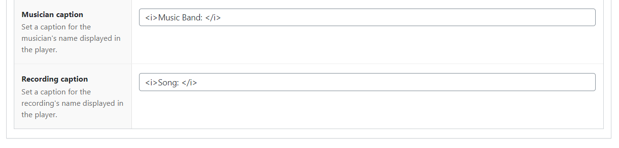

On the **website**:



You can change the style of the e-radio name, the top and bottom image title, the musician’s caption and name, the recording’s caption and name and the warning’s title and message. But we recommend **not overusing this feature**.

## 7.2 Clever images

If you click on the image of the musician in the e-radio, the musician’s description appears. Then, if you get back with the help of the *Back* button, there should be a **different** image than before. In that moment, images are **shuffled** again. It works perfectly only if there are a lot of images to show. Otherwise, you will probably see the same image.

## 7.3 Extended logo

The logo of an e-radio can have its top and bottom title too.



# 8 Contact

If you have any troubles or do not understand something, please contact the author of this plugin.

**Skype:** karelvrabeckv

**E-mail:** [karelvrabeckv@gmail.com](mailto:karelvrabeckv@gmail.com)

Your message helps us to make this user guide and the whole plugin better for understanding.